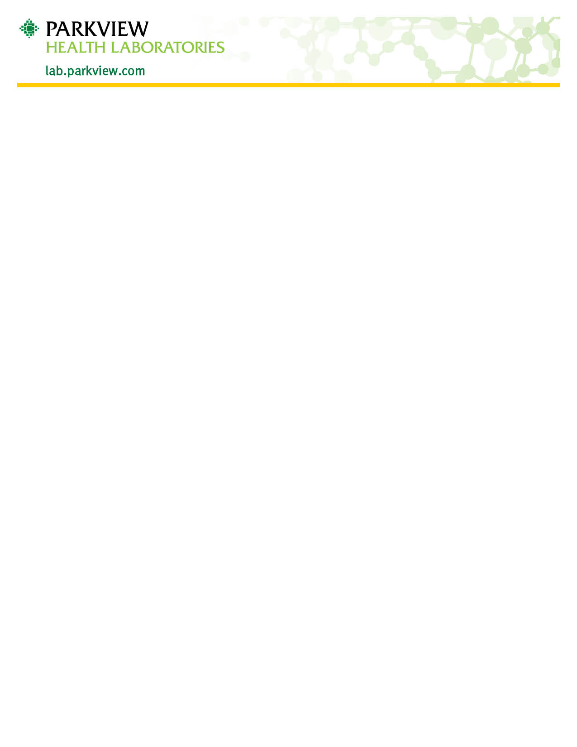
‘

Ova and Parasite Collection Instructions
- You have received 1 to 3 Ova & Parasite Kits; each kit consists of 3 vials, some or all of the vials contain liquid. Do not dispose of the liquid.
- The solutions in the vials are poisonous.
  - Do not drink. Keep out of reach of children.
  - Antidote: In case of skin or eye contact, flush with water. If irritation persists, contact a physician. In case of swallowing, call a physician immediately. If conscious, give milk or egg white beaten with water Induce vomiting with a glass of warm salt water. Repeat until vomit is clear.
- Do not use antacids, barium, bismuth, antidiarrheal medications, or oily laxatives at least 7 to 10 days before collecting any specimens.
- Wait at least 2-3 weeks after taking antibiotic treatment before collecting any specimens.
  - If you have received a gallbladder dye, specimens should be collected 3 weeks after the procedure.
- A single stool specimen should be used to fill all three vials of a kit.
  - If your physician has ordered 3 kits to be collected, they must be collected greater than 48 hours apart and within a 10-day period.
- Collect the stool specimen in a clean, dry wide mouthed container, such as a bedpan, commode hat, or a wastebasket lined with a plastic bag. A clean, dry piece of newspaper or wax paper may also be used.
- Do not pass the specimen directly into the vial.
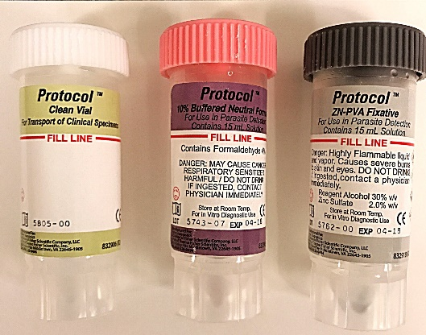
- Do not urinate on the specimen.
- Start with the Pink Capped Vial –
  - Use the spork built into the vial cap to transfer small samples from areas that appear bloody slimy, or watery. If the specimen is firm, take samples from both ends and the middle.
  - Continue adding samples in each vial until the fluid level reaches the red fill line. Do Not Overfill.
  - Mix the content of each vial with the spork. Do not interchange the lid/spork with a different colored vial
  - Recap the vial, making sure the lid is tight. Shake the vial until the contents are well mixed.
- Now Repeat steps 9a thru 9d for the Gray Capped Vial
- If a White Cap vial is provided, fill with sample as directed and recap. Do not mix or shake the contents.
- Fill out the information requested on the side of the vial label. Check the box that most closely resembles the specimen you just collected.
  - The specimen should also be labeled with the patient’s full legal name, date of birth, date and time of collection.
- Wash hands thoroughly after collection and specimen preparation.
- Return each kit to your physician or laboratory as completed.

